Министерство образования Республики Беларусь
Учреждение образования
«Белорусский государственный университет информатики и радиоэлектроники»

Кафедра электронных вычислительных машин

Лабораторная работа №4
по дисциплине «Программирование на языках высокого уровня»
«Error logging/handling»

Выполнил: Снитко Д.А. Проверил: Скиба И.Г.
гр.250501

Минск 2024
1. Постановка задачи

1. Обработать 400 и 500 ошибки.
2. Добавить логирование действий и ошибок (аспекты).
3. Подключить Swagger & CheckStyle. Убрать стилистические ошибки.

2. Структура проекта
В проекте используется послойная архитектура из нескольких пакетов,
которые отвечают за определенные функции.
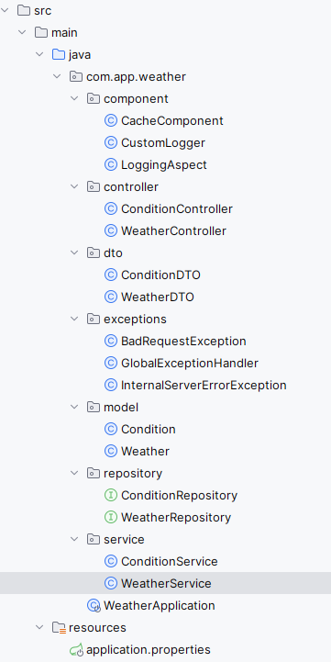
Рисунок 2.1 – Структура проекта
3. Листинг кода

Файл CacheComponent.java
package com.app.weather.component;
import org.springframework.stereotype.Component;
import java.util.HashMap;
import java.util.Map;

@Component
public class CacheComponent {

private final Map<String, Object> hashMap = new HashMap<>();
private final CustomLogger customLogger;

public CacheComponent(CustomLogger customLogger) {
this.customLogger = customLogger;
}

public void put(String key, Object value) {
hashMap.put(key, value);
int maxSize = 100;
if (hashMap.size() > maxSize) {
String oldestKey = hashMap.keySet().iterator().next();
hashMap.remove(oldestKey);
}
customLogger.cachePut();
}

public Object get(String key) {
return hashMap.get(key);
}

public void remove(String key) {
hashMap.remove(key);
customLogger.cacheRemove();
}
}
Файл CustomLogger.java
package com.app.weather.component;

import org.slf4j.Logger;
import org.slf4j.LoggerFactory;
import org.springframework.stereotype.Component;

@Component
public class CustomLogger {

private static final Logger LOGGER = LoggerFactory.getLogger(CustomLogger.class);

public void error(String text) {
LOGGER.error(text);
}

public void info(String text) {
LOGGER.info(text);
}

public void cachePut() {
LOGGER.info("Кэш обновлен (put)");
}

public void cacheRemove() {
LOGGER.info("Кэш обновлен (remove)");
}
}

Файл LoggingAspect.java

package com.app.weather.component;

import org.aspectj.lang.JoinPoint;
import org.aspectj.lang.annotation.AfterThrowing;
import org.aspectj.lang.annotation.Aspect;
import org.aspectj.lang.annotation.Before;
import org.slf4j.Logger;
import org.slf4j.LoggerFactory;
import org.springframework.stereotype.Component;

@Aspect
@Component
public class LoggingAspect {

private static final Logger LOGGER = LoggerFactory.getLogger(LoggingAspect.class);

@Before("execution(* com.app.weather.controller..*.*(..))")
public void logBefore(JoinPoint joinPoint) {
String methodName = joinPoint.getSignature().getName();
LOGGER.info("Начало выполнения метода: {}", methodName);
}

@AfterThrowing(pointcut = "execution(* com.app.weather.controller..*.*(..))", throwing = "exception")
public void logAfterThrowing(JoinPoint joinPoint, Throwable exception) {
String methodName = joinPoint.getSignature().getName();
LOGGER.error("Ошибка в методе: {} с сообщением: {}", methodName, exception.getMessage());
}
}
Файл ConditionController.java
package com.app.weather.controller;

import com.app.weather.component.CustomLogger;
import com.app.weather.dto.ConditionDTO;
import com.app.weather.model.Condition;
import com.app.weather.service.ConditionService;
import org.springframework.http.ResponseEntity;
import org.springframework.web.bind.annotation.*;
import java.util.List;

@RestController
@RequestMapping("/conditions")
public class ConditionController {

private final ConditionService conditionService;
private final CustomLogger customLogger;

public ConditionController(ConditionService conditionService, CustomLogger customLogger) {
this.conditionService = conditionService;
this.customLogger = customLogger;
}

@GetMapping
public ResponseEntity<List<ConditionDTO>> getAllConditions() {
customLogger.info("Получение всех condition");
List<Condition> conditions = conditionService.getAllConditions();
List<ConditionDTO> conditionDTOs = conditions.stream()
.map(conditionService::convertToDTO)
.toList();
return ResponseEntity.ok(conditionDTOs);
}

@GetMapping("/{id}")
public ResponseEntity<ConditionDTO> getConditionById(@PathVariable Long id) {
customLogger.info("Получение condition по id: " + id);
Condition condition = conditionService.getConditionById(id);
if (condition == null) {
return ResponseEntity.notFound().build();
}
return ResponseEntity.ok(conditionService.convertToDTO(condition));
}

@PostMapping
public ResponseEntity<ConditionDTO> createCondition(@RequestBody ConditionDTO conditionDTO) {
customLogger.info("Создание условия");
Condition condition = conditionService.convertToEntity(conditionDTO);
Condition savedCondition = conditionService.createCondition(condition);
return ResponseEntity.ok(conditionService.convertToDTO(savedCondition));
}

@PutMapping("/{id}")
public ResponseEntity<ConditionDTO> updateCondition(@PathVariable Long id, @RequestBody ConditionDTO conditionDTO) {
customLogger.info("Обновление condition с id: " + id);
Condition updatedCondition = conditionService.updateCondition(id, conditionDTO);
if (updatedCondition == null) {
return ResponseEntity.notFound().build();
}
return ResponseEntity.ok(conditionService.convertToDTO(updatedCondition));
}

@DeleteMapping("/{id}")
public ResponseEntity<Void> deleteCondition(@PathVariable Long id) {
customLogger.info("Удаление condition с id: " + id);
if (!conditionService.deleteCondition(id)) {
return ResponseEntity.notFound().build();
}
return ResponseEntity.noContent().build();
}
}
Файл WeatherController.java
package com.app.weather.controller;

import com.app.weather.component.CustomLogger;
import com.app.weather.dto.WeatherDTO;
import com.app.weather.model.Weather;
import com.app.weather.service.WeatherService;
import org.springframework.http.ResponseEntity;
import org.springframework.web.bind.annotation.*;
import java.util.List;

@RestController
@RequestMapping("/weather")
public class WeatherController {

private final WeatherService weatherService;
private final CustomLogger customLogger;

public WeatherController(WeatherService weatherService, CustomLogger customLogger) {
this.weatherService = weatherService;
this.customLogger = customLogger;
}

@GetMapping
public ResponseEntity<List<WeatherDTO>> getAllWeathers() {
customLogger.info("Получение всех weather");
List<Weather> weathers = weatherService.getAllWeathers();
List<WeatherDTO> weatherDTOs = weathers.stream()
.map(weatherService::convertToDTO)
.toList();
return ResponseEntity.ok(weatherDTOs);
}

@GetMapping("/{id}")
public ResponseEntity<WeatherDTO> getWeatherById(@PathVariable Long id) {
customLogger.info("Получение weather по id: " + id);
Weather weather = weatherService.getWeatherById(id);
if (weather == null) {
return ResponseEntity.notFound().build();
}
return ResponseEntity.ok(weatherService.convertToDTO(weather));
}

//Query
@GetMapping("/citiesT/{temperature}")
public ResponseEntity<List<WeatherDTO>> getWeatherByTemperature(@PathVariable double temperature) {
customLogger.info("Получение weather по температуре: " + temperature);
List<WeatherDTO> weatherDTOs = weatherService.findByTemperature(temperature);
return ResponseEntity.ok(weatherDTOs);
}

@GetMapping("/citiesC/{conditionText}")
public ResponseEntity<List<WeatherDTO>> findByConditionText(@PathVariable String conditionText) {
customLogger.info("Получение condition по тексту условия: " + conditionText);
List<WeatherDTO> weathers = weatherService.findByConditionText(conditionText);
return ResponseEntity.ok(weathers);
}

@PostMapping
public ResponseEntity<WeatherDTO> createWeatherWithConditionText(@RequestBody WeatherDTO weatherDTO) {
customLogger.info("Создание weather с condition");
Weather createdWeather = weatherService.createWeatherWithCondition(weatherDTO);
return ResponseEntity.ok(weatherService.convertToDTO(createdWeather));
}

@PutMapping("/{id}")
public ResponseEntity<WeatherDTO> updateWeather(@PathVariable Long id, @RequestBody WeatherDTO weatherDTO) {
customLogger.info("Обновление weather с id: " + id);
Weather weather = weatherService.updateWeather(id, weatherDTO);
if (weather == null) {
return ResponseEntity.notFound().build();
}
return ResponseEntity.ok(weatherService.convertToDTO(weather));
}

@DeleteMapping("/{id}")
public ResponseEntity<Void> deleteWeather(@PathVariable Long id) {
customLogger.info("Удаление weather с id: " + id);
weatherService.deleteWeather(id);
return ResponseEntity.noContent().build();
}

}
Файл ConditionDTO.java
package com.app.weather.dto;

import lombok.*;

@Getter
@Setter
@AllArgsConstructor
@NoArgsConstructor
public class ConditionDTO {
private Long id;
private String text;

}
Файл ConditionDTO.java
package com.app.weather.dto;

import lombok.*;
import java.sql.Timestamp;

@Getter
@Setter
@AllArgsConstructor
@NoArgsConstructor
public class WeatherDTO {
private Long id;
private String city;
private Timestamp date;
private double temperature;
private ConditionDTO condition;
}

Файл BadRequestException.java
package com.app.weather.exceptions;

public class BadRequestException extends RuntimeException {

public BadRequestException(String message) {
super(message);
}
}
Файл GlobalExceptionHandler.java
package com.app.weather.exceptions;

import com.app.weather.component.CustomLogger;
import org.springframework.http.HttpStatus;
import org.springframework.http.ResponseEntity;
import org.springframework.web.bind.annotation.ControllerAdvice;
import org.springframework.web.bind.annotation.ExceptionHandler;

@ControllerAdvice
public class GlobalExceptionHandler {

private final CustomLogger customLogger;

public GlobalExceptionHandler(CustomLogger customLogger) {
this.customLogger = customLogger;
}

@ExceptionHandler(BadRequestException.class)
public ResponseEntity<String> handleBadRequestException(BadRequestException e) {
customLogger.error(e.getMessage());
return new ResponseEntity<>(e.getMessage(), HttpStatus.BAD_REQUEST);
}

@ExceptionHandler(InternalServerErrorException.class)
public ResponseEntity<String> handleInternalServerErrorException(InternalServerErrorException e) {
customLogger.error(e.getMessage());
return new ResponseEntity<>(e.getMessage(), HttpStatus.INTERNAL_SERVER_ERROR);
}
}
Файл InternalServerErrorException.java
package com.app.weather.exceptions;

public class InternalServerErrorException extends RuntimeException {

public InternalServerErrorException(String message) {
super(message);
}
}
Файл Condition.java

package com.app.weather.model;

import jakarta.persistence.*;
import lombok.*;
import java.util.ArrayList;
import java.util.List;

@Entity
@Table(name = "condition")
@Getter
@Setter
@AllArgsConstructor
@NoArgsConstructor
public class Condition {

@Id
@GeneratedValue(strategy = GenerationType.IDENTITY)
private Long id;

@Column(name = "text")
private String text;

// Двунаправленная связь One-to-Many
@OneToMany(mappedBy = "condition", cascade = CascadeType.ALL, orphanRemoval = true)
private List<Weather> weathers = new ArrayList<>();

public void addWeather(Weather weather) {
weathers.add(weather);
weather.setCondition(this);
}

}
Файл Weather.java
package com.app.weather.model;

import jakarta.persistence.*;
import lombok.*;
import java.sql.Timestamp;

@Entity
@Table(name = "weather")
@Getter
@Setter
@AllArgsConstructor
@NoArgsConstructor
public class Weather {

@Id
@GeneratedValue(strategy = GenerationType.IDENTITY)
private Long id;

@Column(name = "date")
private Timestamp date;

@Column(name = "city")
private String city;

@Column(name = "temperature")
private double temperature;

// Двунаправленная связь Many-to-One
@ManyToOne
@JoinColumn(name = "condition_id")
private Condition condition;
}
Файл ConditionRepository.java
package com.app.weather.repository;

import com.app.weather.model.Condition;
import org.springframework.data.jpa.repository.JpaRepository;
import org.springframework.stereotype.Repository;

@Repository
public interface ConditionRepository extends JpaRepository<Condition, Long> {
Condition findByText(String text);

boolean existsByText(String text);

boolean existsByTextAndIdNot(String text, Long id);

}
Файл WeatherRepository.java
package com.app.weather.repository;
import com.app.weather.model.Weather;
import org.springframework.data.jpa.repository.JpaRepository;
import org.springframework.data.jpa.repository.Query;
import org.springframework.data.repository.query.Param;
import org.springframework.stereotype.Repository;
import java.util.List;

@Repository
public interface WeatherRepository extends JpaRepository<Weather, Long> {
Weather findByCity(String city);

boolean existsByCity(String city);

boolean existsByCityAndIdNot(String city, Long id);

//JPQL
@Query("SELECT w FROM Weather w WHERE w.temperature = :temperature")
List<Weather> findByTemperature(@Param("temperature") double temperature);

@Query("SELECT w FROM Weather w JOIN w.condition c WHERE c.text = :conditionText")
List<Weather> findByConditionText(@Param("conditionText") String conditionText);
}
Файл ConditionService.java
package com.app.weather.service;

import com.app.weather.component.CacheComponent;
import com.app.weather.component.CustomLogger;
import com.app.weather.dto.ConditionDTO;
import com.app.weather.exceptions.BadRequestException;
import com.app.weather.exceptions.InternalServerErrorException;
import com.app.weather.model.Condition;
import com.app.weather.repository.ConditionRepository;
import org.springframework.beans.factory.annotation.Autowired;
import org.springframework.context.ApplicationContext;
import org.springframework.stereotype.Service;
import org.springframework.transaction.annotation.Transactional;
import java.util.List;

@Service
public class ConditionService {

private static final String notFoundMsg = "Condition not found";
private final ConditionRepository conditionRepository;
private final CacheComponent cache;
private final CustomLogger customLogger;
private String cacheKey;
private final ApplicationContext applicationContext;

@Autowired
public ConditionService(ConditionRepository conditionRepository, CacheComponent cache, CustomLogger customLogger, ApplicationContext applicationContext) {
this.conditionRepository = conditionRepository;
this.cache = cache;
this.customLogger = customLogger;
this.applicationContext = applicationContext;
}

@Transactional
public Condition createCondition(Condition condition) {
customLogger.info("Creating condition");
if (conditionRepository.existsByText(condition.getText())) {
throw new BadRequestException("Condition with this text already exists");
}
Condition savedCondition = conditionRepository.save(condition);
cacheKey = savedCondition.getId().toString();
cache.put(cacheKey, savedCondition);
return savedCondition;
}

@Transactional
public Condition updateCondition(Long id, ConditionDTO conditionDTO) {
customLogger.info("Updating condition with id: " + id);
Condition existingCondition = getConditionService().getConditionById(id);
if (existingCondition == null) {
throw new BadRequestException(notFoundMsg);
}
if (conditionRepository.existsByTextAndIdNot(conditionDTO.getText(), id)) {
throw new BadRequestException("Condition with this text already exists");
}
existingCondition.setText(conditionDTO.getText());
Condition savedCondition = conditionRepository.save(existingCondition);
cacheKey = savedCondition.getId().toString();
cache.put(cacheKey, savedCondition);
return savedCondition;
}

@Transactional
public boolean deleteCondition(Long id) {
customLogger.info("Deleting condition with id: " + id);
if (!conditionRepository.existsById(id)) {
throw new BadRequestException(notFoundMsg);
}
conditionRepository.deleteById(id);
cacheKey = id.toString();
cache.remove(cacheKey);
return true;
}

@Transactional
public Condition getConditionById(Long id) {
customLogger.info("Getting condition by id: {}" + id);
try {
cacheKey = id.toString();
Condition condition = (Condition) cache.get(cacheKey);
if (condition != null) {
return condition;
}
condition = conditionRepository.findById(id).orElse(null);
if (condition != null) {
cache.put(cacheKey, condition);
} else {
throw new BadRequestException(notFoundMsg);
}
return condition;
} catch (Exception e) {
throw new InternalServerErrorException("Failed to get condition by id");
}
}

@Transactional
public List<Condition> getAllConditions() {
customLogger.info("Getting all conditions");
try {
List<Condition> conditions = conditionRepository.findAll();
conditions.forEach(condition -> {
cacheKey = condition.getId().toString();
cache.put(cacheKey, condition);
});
return conditions;
} catch (Exception e) {
throw new InternalServerErrorException("Failed to get all conditions");
}
}

public Condition convertToEntity(ConditionDTO conditionDTO) {
customLogger.info("Converting ConditionDTO to Condition");
Condition condition = new Condition();
condition.setText(conditionDTO.getText());
return condition;
}

public ConditionDTO convertToDTO(Condition condition) {
customLogger.info("Converting Condition to ConditionDTO");
if (condition == null) {
return null;
}
return new ConditionDTO(condition.getId(), condition.getText());
}

@Transactional

public Condition getConditionByText(String text) {
customLogger.info("Getting condition by text: " + text);
try {
Condition condition = conditionRepository.findByText(text);
if (condition != null) {
cacheKey = condition.getId().toString();
cache.put(cacheKey, condition);
}
return condition;
} catch (Exception e) {
throw new InternalServerErrorException("Failed to get condition by text");
}
}

private ConditionService getConditionService() {
return applicationContext.getBean(ConditionService.class);
}
}}
Файл WeatherService.java
package com.app.weather.service;

import com.app.weather.component.CacheComponent;
import com.app.weather.component.CustomLogger;
import com.app.weather.dto.ConditionDTO;
import com.app.weather.dto.WeatherDTO;
import com.app.weather.exceptions.BadRequestException;
import com.app.weather.exceptions.InternalServerErrorException;
import com.app.weather.model.Condition;
import com.app.weather.model.Weather;
import com.app.weather.repository.WeatherRepository;
import org.springframework.context.ApplicationContext;
import java.sql.Timestamp;
import java.util.List;
import org.springframework.beans.factory.annotation.Autowired;
import org.springframework.stereotype.Service;
import org.springframework.transaction.annotation.Transactional;

@Service
public class WeatherService {
private static final String NOT_FOUND_MSG = "Weather not found";
private final WeatherRepository weatherRepository;
private final ConditionService conditionService;
private final CacheComponent cache;
private final CustomLogger customLogger;
private String cacheKey;
private final ApplicationContext applicationContext;

@Autowired
public WeatherService(WeatherRepository weatherRepository, ConditionService conditionService, CacheComponent cache, CustomLogger customLogger, ApplicationContext applicationContext) {
this.weatherRepository = weatherRepository;
this.conditionService = conditionService;
this.cache = cache;
this.customLogger = customLogger;
this.applicationContext = applicationContext;
}

@Transactional
public Weather createWeatherWithCondition(WeatherDTO weatherDTO) {
customLogger.info("Creating weather with condition");
if (weatherRepository.existsByCity(weatherDTO.getCity())) {
throw new BadRequestException("Weather for this city already exists");
}
try {
Weather weather = convertToEntity(weatherDTO);
weather.setDate(new Timestamp(System.currentTimeMillis()));

cacheKey = weather.getCity();

// Проверяем, существует ли уже погода для этого города
Weather existingWeather = (Weather) cache.get(cacheKey);
if (existingWeather != null) {
return existingWeather;
}
Weather weatherFromDb = weatherRepository.findByCity(weather.getCity());
if (weatherFromDb != null) {
cache.put(cacheKey, weatherFromDb);
return weatherFromDb;
}
// Проверяем, существует ли условие, если нет, то создаем его
Condition condition = conditionService.getConditionByText(weatherDTO.getCondition().getText());
if (condition == null) {
condition = conditionService.convertToEntity(weatherDTO.getCondition());
condition = conditionService.createCondition(condition); // сохраняем объект Condition в базе данных
}

// Устанавливаем связь между погодой и условием
weather.setCondition(condition);
condition.addWeather(weather);

// Создаем новую погоду
Weather savedWeather = weatherRepository.save(weather);
cache.put(cacheKey, savedWeather);
return savedWeather;
} catch (Exception e) {
throw new InternalServerErrorException("Failed to create weather with condition");
}
}

@Transactional
public Weather updateWeather(Long id, WeatherDTO weatherDTO) {
customLogger.info("Updating weather with id: " + id);
Weather existingWeather = getWeatherService().getWeatherById(id);
if (existingWeather == null) {
throw new BadRequestException(NOT_FOUND_MSG);
}
if (weatherRepository.existsByCityAndIdNot(weatherDTO.getCity(), id)) {
throw new BadRequestException("Weather for this city already exists");
}
try {
existingWeather.setDate(new Timestamp(System.currentTimeMillis()));
existingWeather.setTemperature(weatherDTO.getTemperature());
cacheKey = existingWeather.getCity();

// Проверяем, существует ли уже погода для этого города
Weather weatherByCity = weatherRepository.findByCity(weatherDTO.getCity());
if (weatherByCity != null && !weatherByCity.getId().equals(id)) {
return weatherByCity;
}

// Проверяем, существует ли условие, если нет, то создаем его
Condition condition = conditionService.getConditionByText(weatherDTO.getCondition().getText());
if (condition == null) {
condition = conditionService.convertToEntity(weatherDTO.getCondition());
}
existingWeather.setCondition(condition);

Weather savedWeather = weatherRepository.save(existingWeather);
cache.put(cacheKey, savedWeather);
return savedWeather;
} catch (Exception e) {
throw new InternalServerErrorException("Failed to update weather");
}
}

@Transactional
public void deleteWeather(Long id) {
customLogger.info("Deleting weather with id: {}" + id);
Weather weather = getWeatherService().getWeatherById(id);
if (weather == null) {
throw new BadRequestException(NOT_FOUND_MSG);
}
weatherRepository.delete(weather);
cacheKey = weather.getCity();
cache.remove(cacheKey);
}

@Transactional
public Weather getWeatherById(Long id) {
customLogger.info("Getting weather by id: " + id);
try {
Weather weather = weatherRepository.findById(id).orElse(null);
if (weather == null) {
throw new BadRequestException(NOT_FOUND_MSG);
}
cacheKey = weather.getCity();
cache.put(cacheKey, weather);
return weather;
} catch (Exception e) {
throw new InternalServerErrorException("Failed to get weather by id");
}
}

@Transactional
public List<Weather> getAllWeathers() {
customLogger.info("Getting all weathers");
try {
List<Weather> weathers = weatherRepository.findAll();
weathers.forEach(weather -> {
cacheKey = weather.getCity();
cache.put(cacheKey, weather);
});
return weathers;
} catch (Exception e) {
throw new InternalServerErrorException("Failed to get all weathers");
}
}

public WeatherDTO convertToDTO(Weather weather) {
customLogger.info("Converting Weather to WeatherDTO");
WeatherDTO dto = new WeatherDTO();
dto.setId(weather.getId());
dto.setCity(weather.getCity());
dto.setDate(weather.getDate());
dto.setTemperature(weather.getTemperature());

ConditionDTO conditionDTO = conditionService.convertToDTO(weather.getCondition());
dto.setCondition(conditionDTO);
return dto;
}

private Weather convertToEntity(WeatherDTO weatherDTO) {
customLogger.info("Converting WeatherDTO to Weather");
Weather weather = new Weather();
weather.setCity(weatherDTO.getCity());
weather.setDate(weatherDTO.getDate());
weather.setTemperature(weatherDTO.getTemperature());
// Создаем объект Condition на основе conditionText
Condition condition = new Condition();
condition.setText(weatherDTO.getCondition().getText());
weather.setCondition(condition);
return weather;
}

public List<WeatherDTO> findByTemperature(double temperature) {
customLogger.info("Getting weathers by temperature: " + temperature);
try {
List<Weather> weathers = weatherRepository.findByTemperature(temperature);
return weathers.stream()
.map(this::convertToDTO)
.toList();
} catch (Exception e) {
throw new InternalServerErrorException("Failed to find weathers by temperature");
}
}

public List<WeatherDTO> findByConditionText(String conditionText) {
customLogger.info("Getting weathers by condition text: " + conditionText);
try {
List<Weather> weathers = weatherRepository.findByConditionText(conditionText);
return weathers.stream()
.map(this::convertToDTO)
.toList();
} catch (Exception e) {
throw new InternalServerErrorException("Failed to find weathers by condition text");
}
}

private WeatherService getWeatherService() {
return applicationContext.getBean(WeatherService.class);
}
}

4. Результат программы

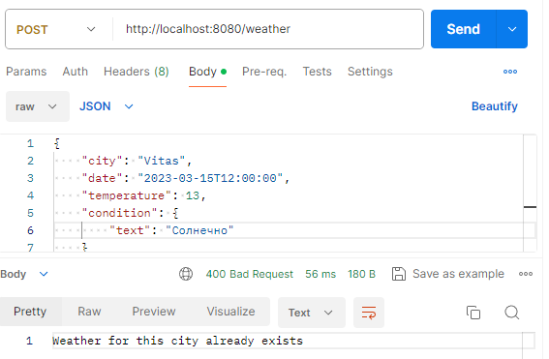
Рисунок 1.1 – обработка ошибки 400

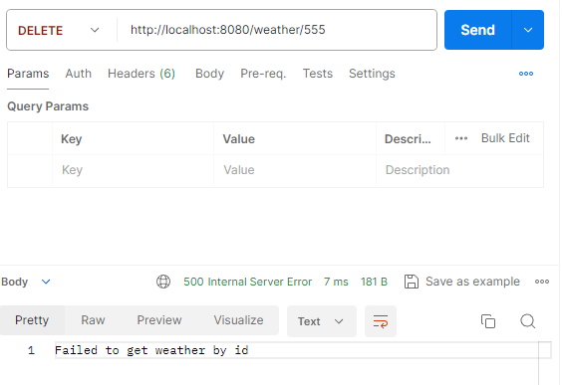
Рисунок 1.2 – обработка ошибки 500

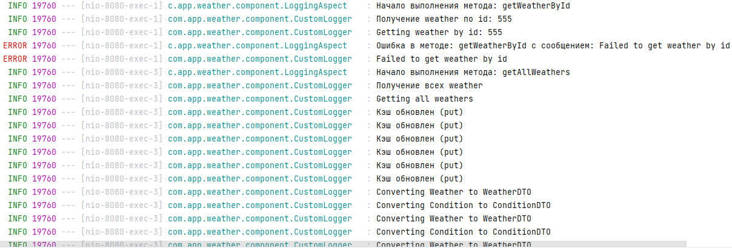
Рисунок 1.3 – логирование действий и ошибок

5. Заключение

В результате работы обработаны ошибки 400 и 500, добавлены соответствующие обработчики в контроллер и настроены сообщения об ошибках. Добавлено логирование действий и ошибок с использованием аспектов. Для этого были созданы соответствующие аспекты и настроены необходимые параметры логирования. Подключен Swagger для документирования API. Были устранены стилистические ошибки с помощью CheckStyle. Для этого были настроены необходимые параметры в файле конфигурации CheckStyle и устранены все обнаруженные ошибки.

